# How to Use BLE Dongle

This document lists down the steps to program and use the BLE Dongle, to be used with Study Watch.

Contents

How to Use BLE Dongle 1

Prepare nRF PCA10059 as the BLE Dongle 1

Prepare nRF DK PCA10056 as BLE Dongle (Optional) 3

Preparing new Dongle firmware 4

Procedure to test CLI over BLE for study watch 4

Prepare the study watch 4

Connect the dongle to the target 4

Run CLI commands over BLE 5

## Prepare nRF PCA10059 as the BLE Dongle

1. Download and install nRFConnect Programmer PC tool going through the following link:

<https://infocenter.nordicsemi.com/index.jsp?topic=%2Fug_nc_programmer%2FUG%2Fcommon%2Fnrf_connect_app_installing.html>

1. Press RESET button on the board(can be seen labeled as RESET, from left side of Figure below), to see the RED light coming.

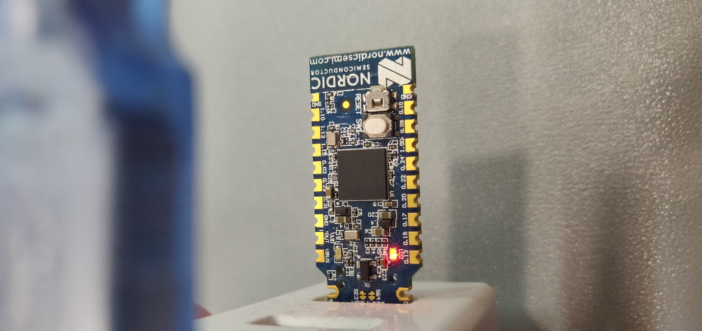

1. From nRF Connect Programmer, go to top left drop down for ‘Select Device’ and select the COM Port getting shown for the board as in Figure below.

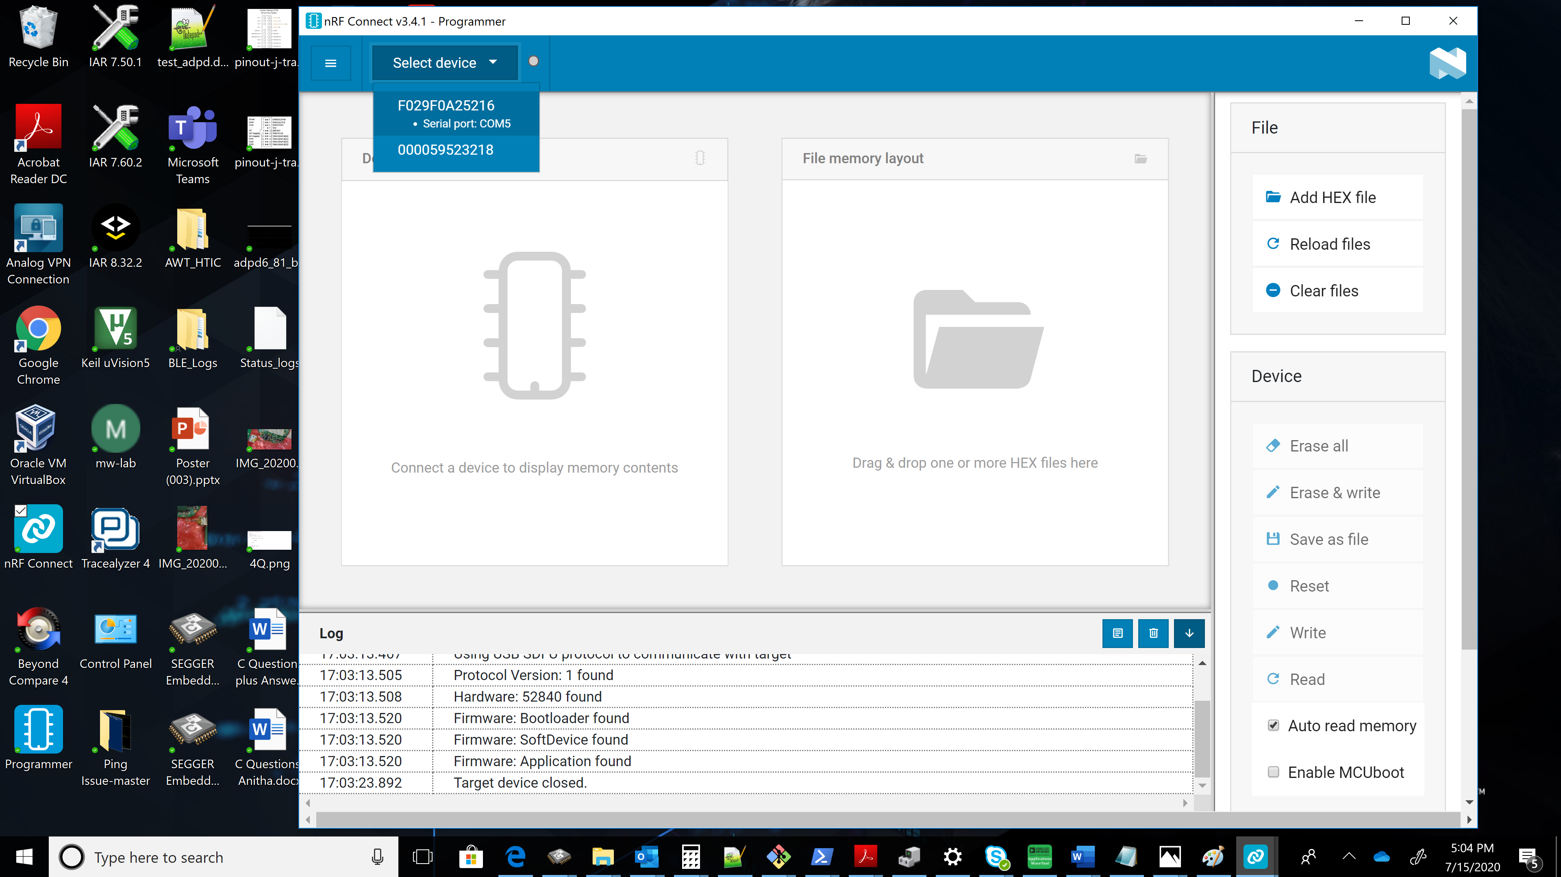

1. From the right-side pane, File -> select Add HEX File and choose the path to study_watch\nrf5_sdk_15.2.0\adi_study_watch\tst\ble_dongle\dongle_test_hex\ ADIBLEDongle_S140.hex which is available in study watch repository.
2. After that from right side pane, Device -> select Write option.

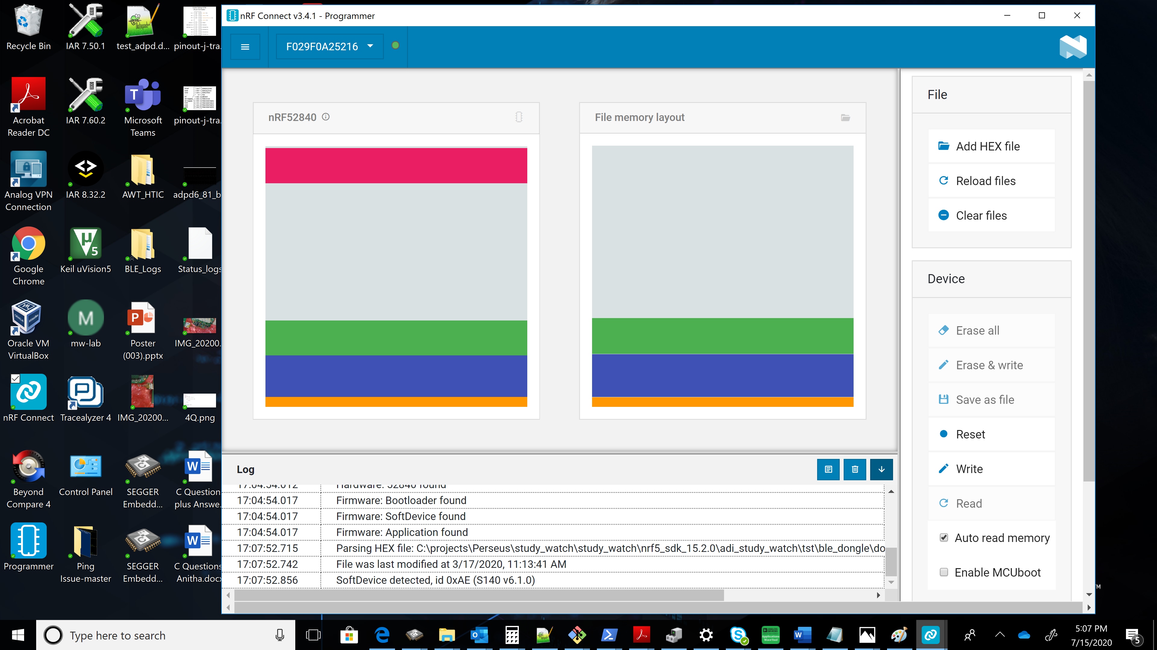

1. This would program the nRF device as a Dongle with selected hex file. At the end, it would be reset, and Dongle is ready to be used.
2. Note the COM port number of Dongle. This will be used to start the CLI over BLE or to connect from AWT.

## Prepare nRF DK PCA10056 as BLE Dongle (Optional)

This section is optional, need to be followed, only if you want to program a nRF DK board as a BLE Dongle. It maybe skipped if you have the Dongle prepared already.

1. Download and install nRFConnect Programmer PC tool going through the following link:

<https://infocenter.nordicsemi.com/index.jsp?topic=%2Fug_nc_programmer%2FUG%2Fcommon%2Fnrf_connect_app_installing.html>

1. Use dongle_test_hex\ADIBLEDongle_S140.hex to program the nRF DK as BLE Dongle from nRF Connect Programmer PC tool.

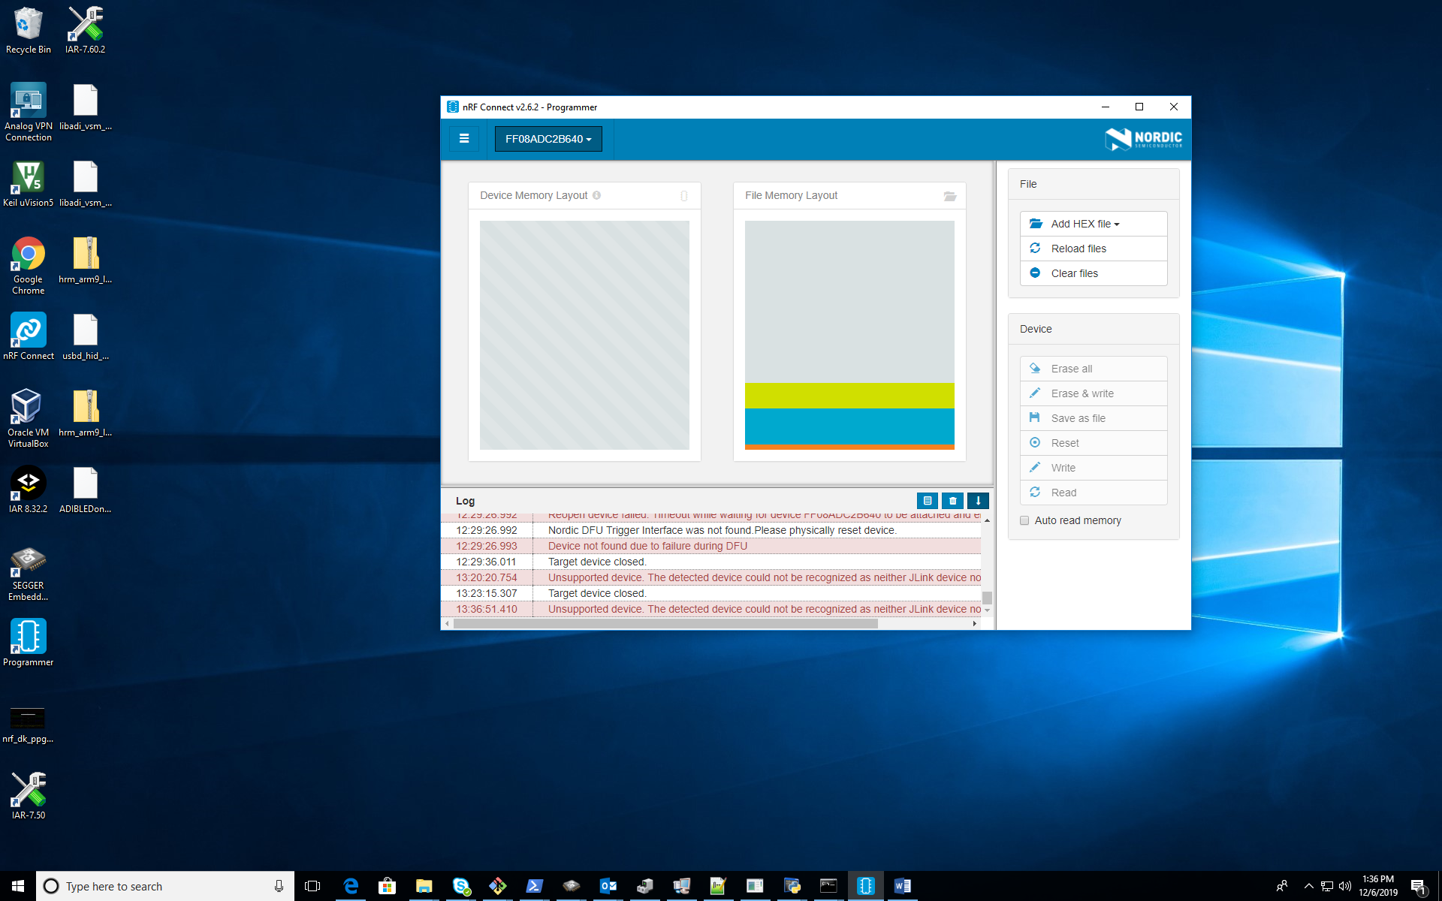

1. Connect the nRF DK though USB cable to PC. Note the COM port number of Dongle. This will be used to start the CLI over BLE

## Preparing new Dongle firmware

This section is needed only if you intend to modify and use the BLE Dongle firmware code and maybe skipped if you are using the test Dongle hex file from study Watch repository.

1. Clone BLE dongle project from <https://bitbucket-ext.analog.com/projects/PERSEUS/repos/adibledongle/browse>
2. Open BLE Dongle SES project from path:

ble_dongle\adibledongle\PoC\device\src\nrf52840\project\ses\adi_dongle_nrf52840.emProject. Build it.

1. Copy hex file hence generated from the path: ble_dongle\adibledongle\PoC\device\src\nrf52840\project\ses\Output\Release\Exe\ adi_dongle_nrf52840.hex
2. This needs to be merged with softdevice hex file to create the Dongle binary.

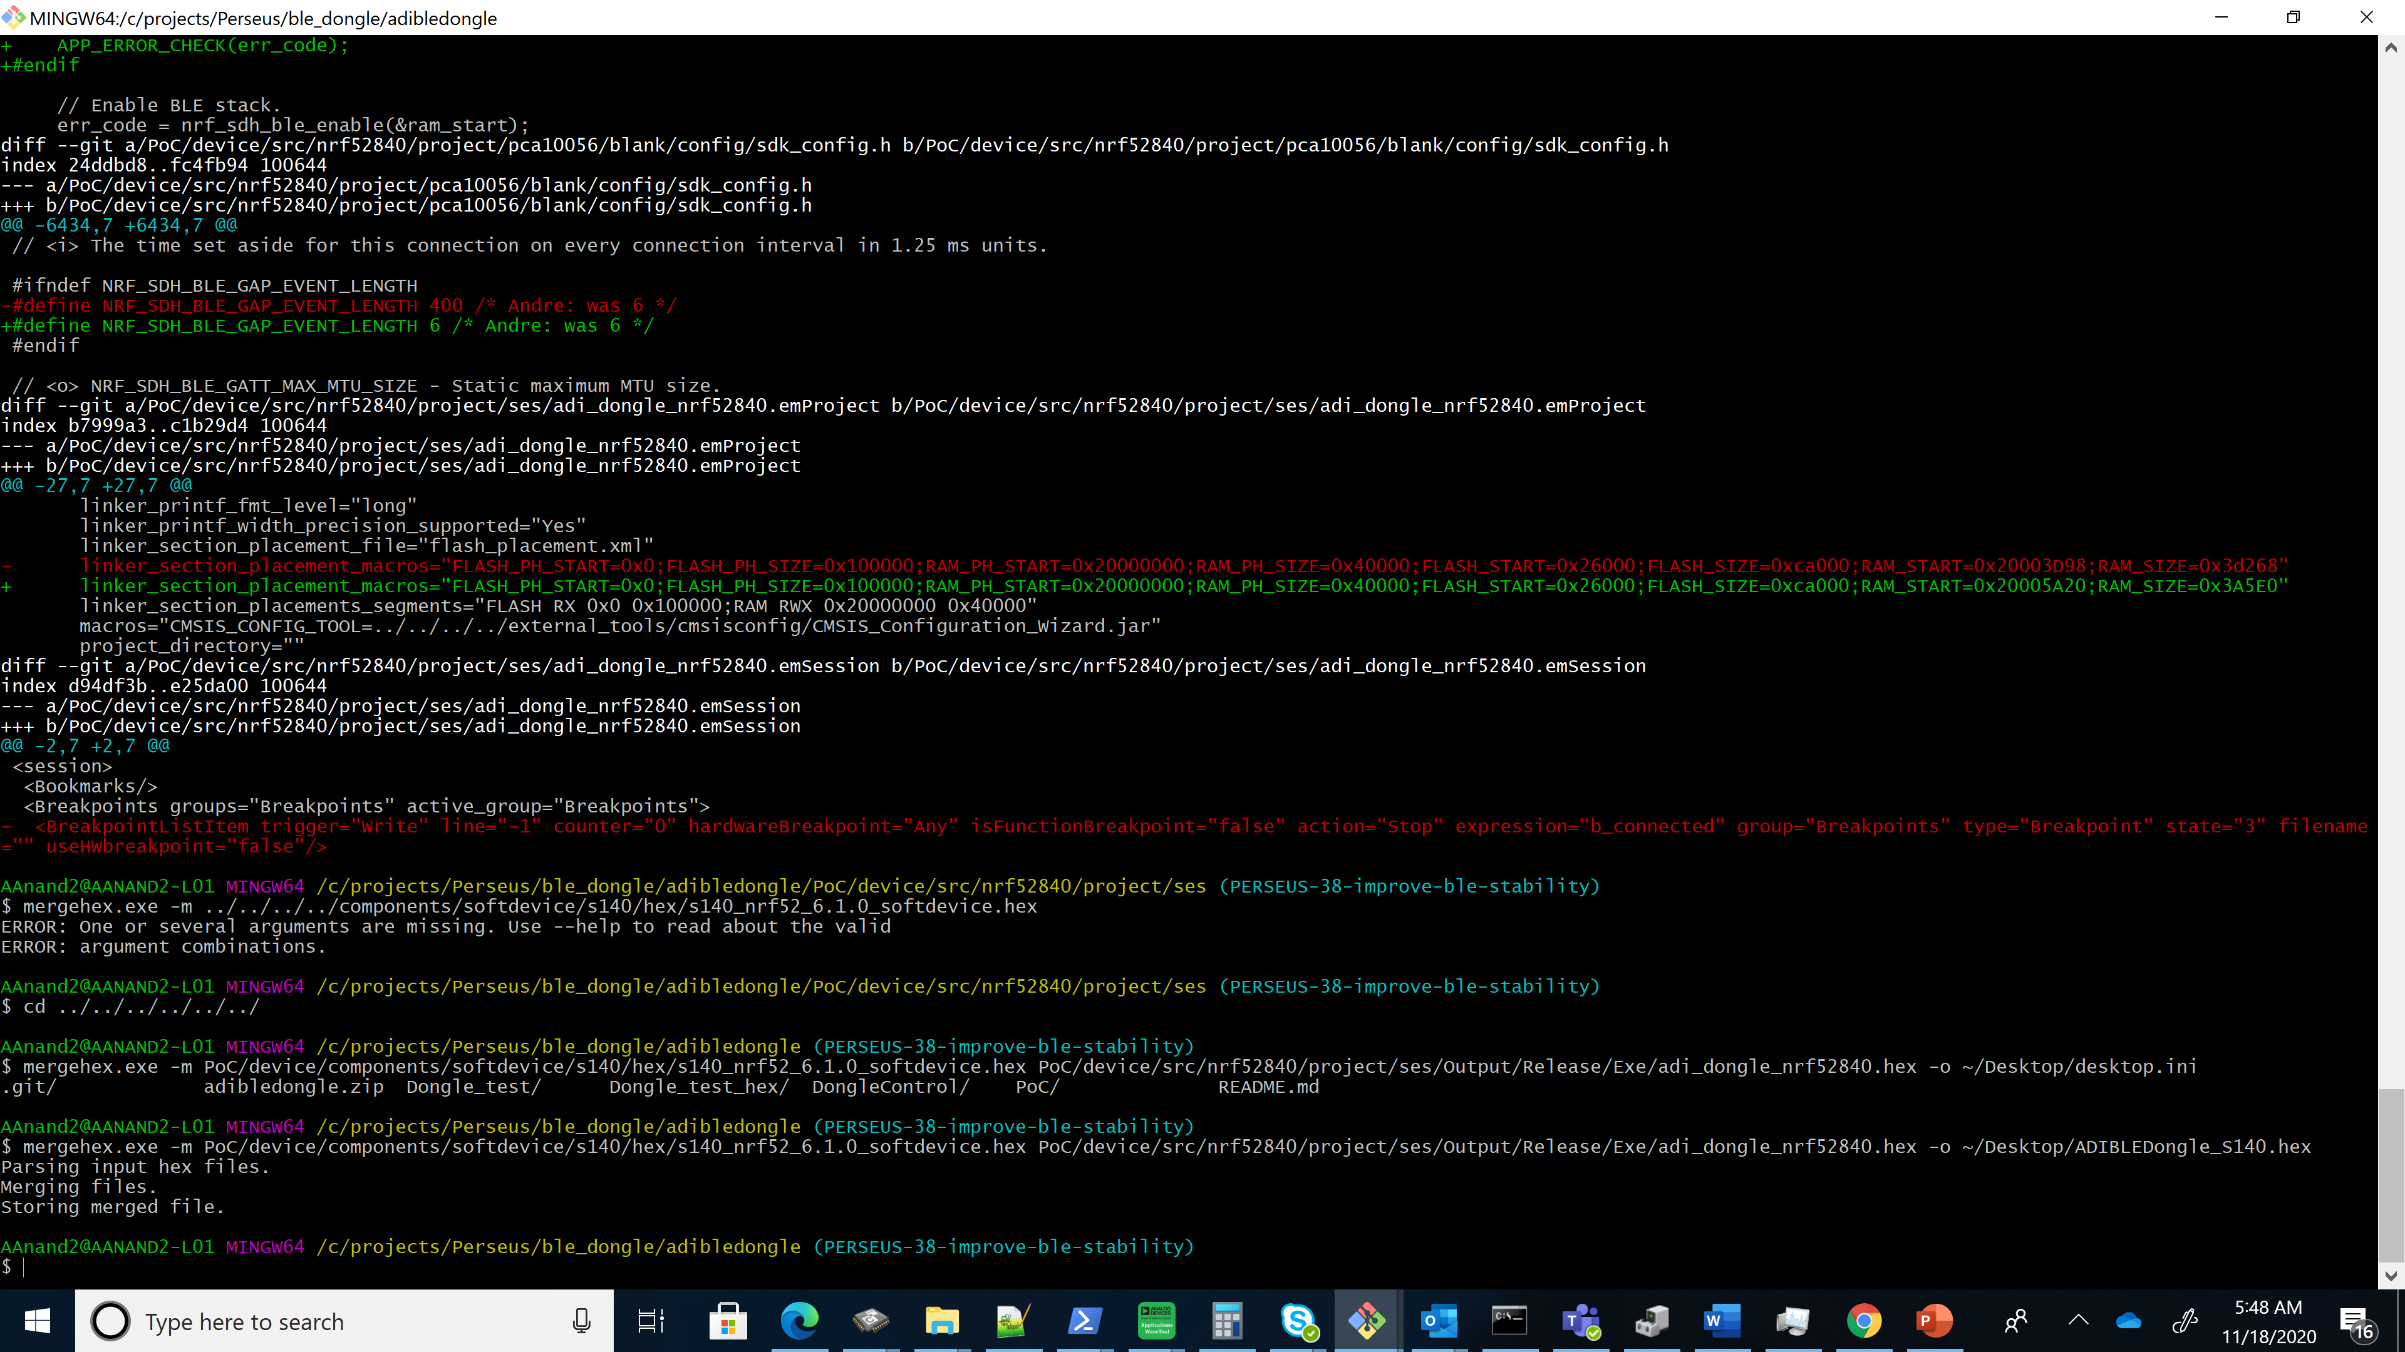

Mege.exe is part of nrf utility

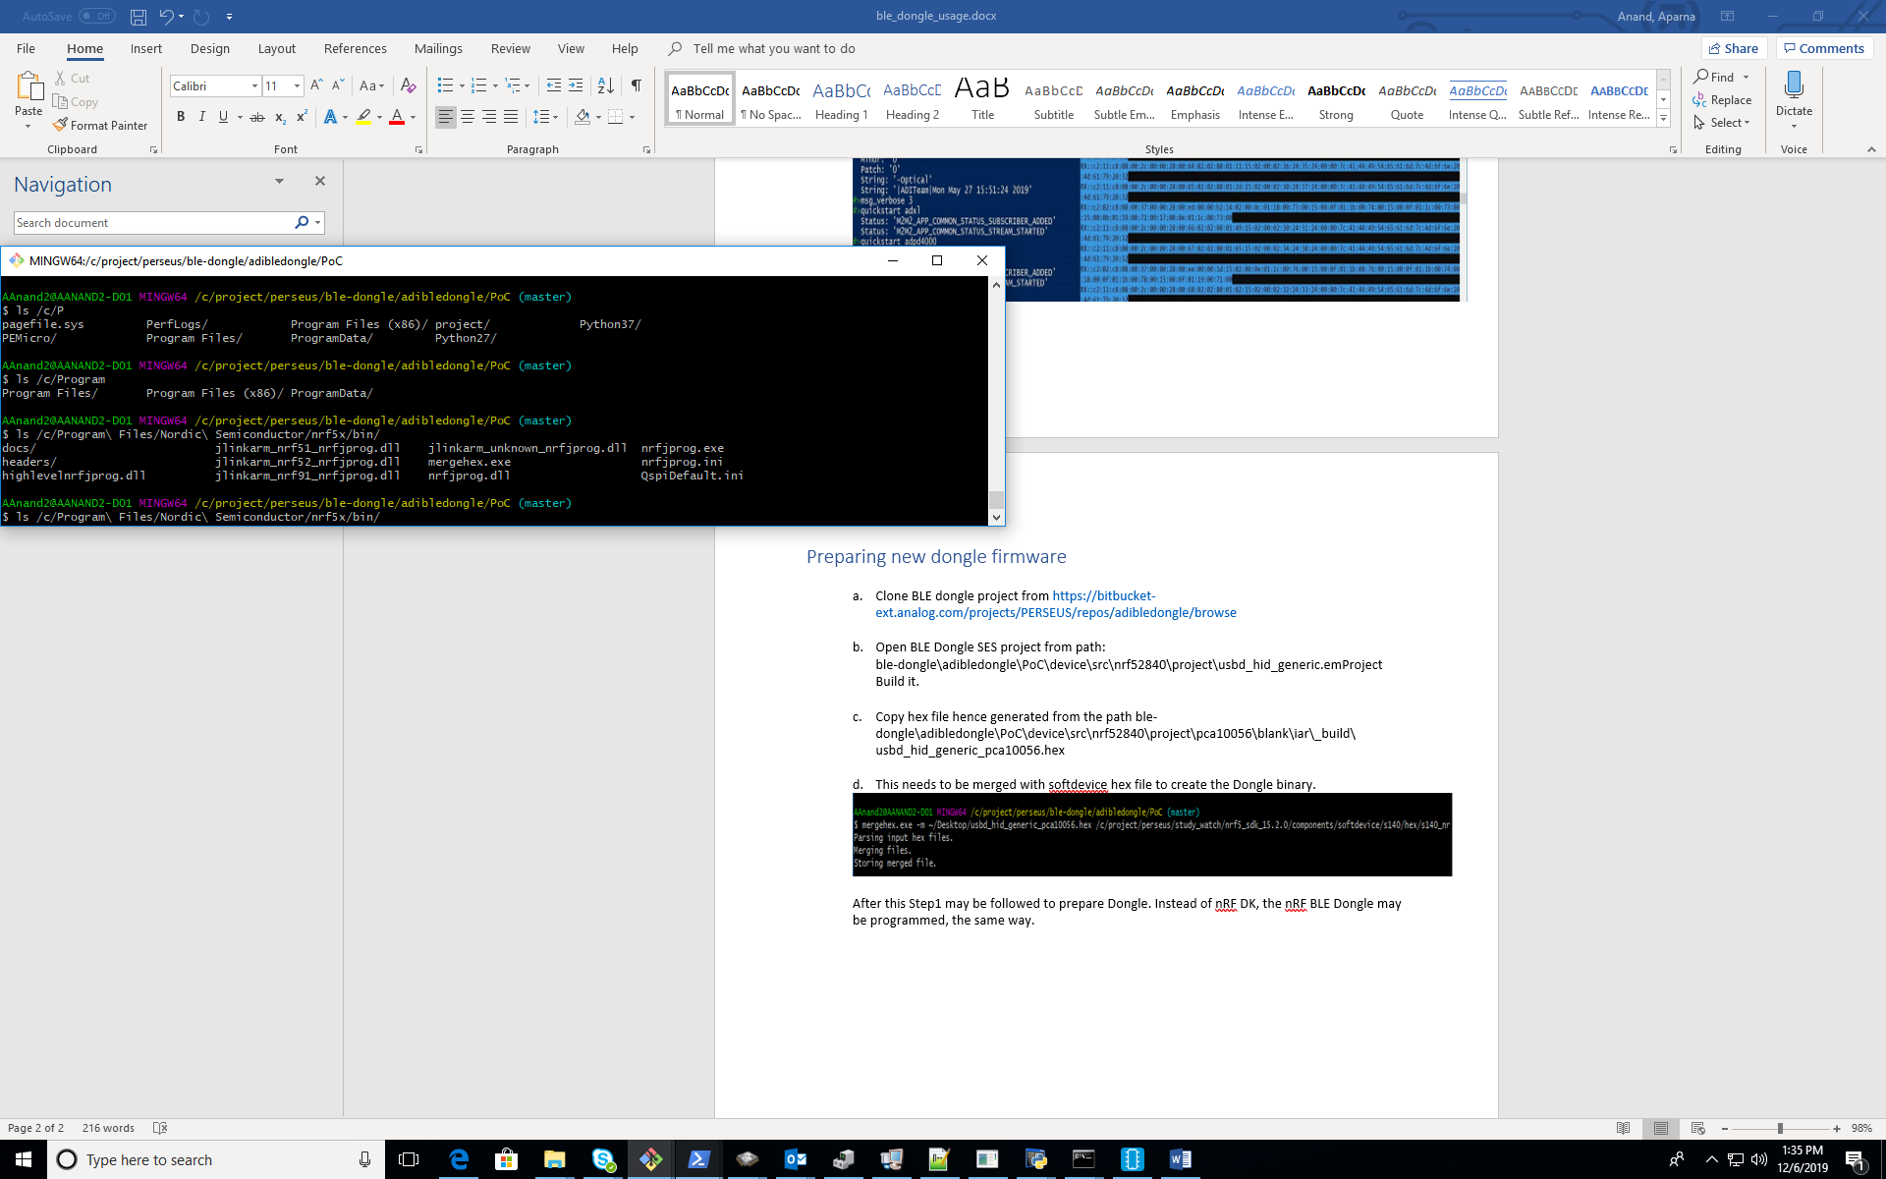

After this, Prepare nRF PCA10059 as the BLE Dongle or Prepare nRF DK PCA10056 as BLE Dongle (Optional) section of the document may be followed to prepare the BLE Dongle.

## Procedure to test CLI over BLE for study watch

### Prepare the study watch

* Program the study watch firmware and verify once from a mobile application (nRF Connect on Android phone) that it gets scanned and listed as “STUDYWATCH_ 58D7AD2A3BD6”

### Connect the dongle to the target

* Run dongle_control\HIDSample.exe from Windows Power Shell.
* Use BLE Dongle and HIDSample.exe to connect with Watch.

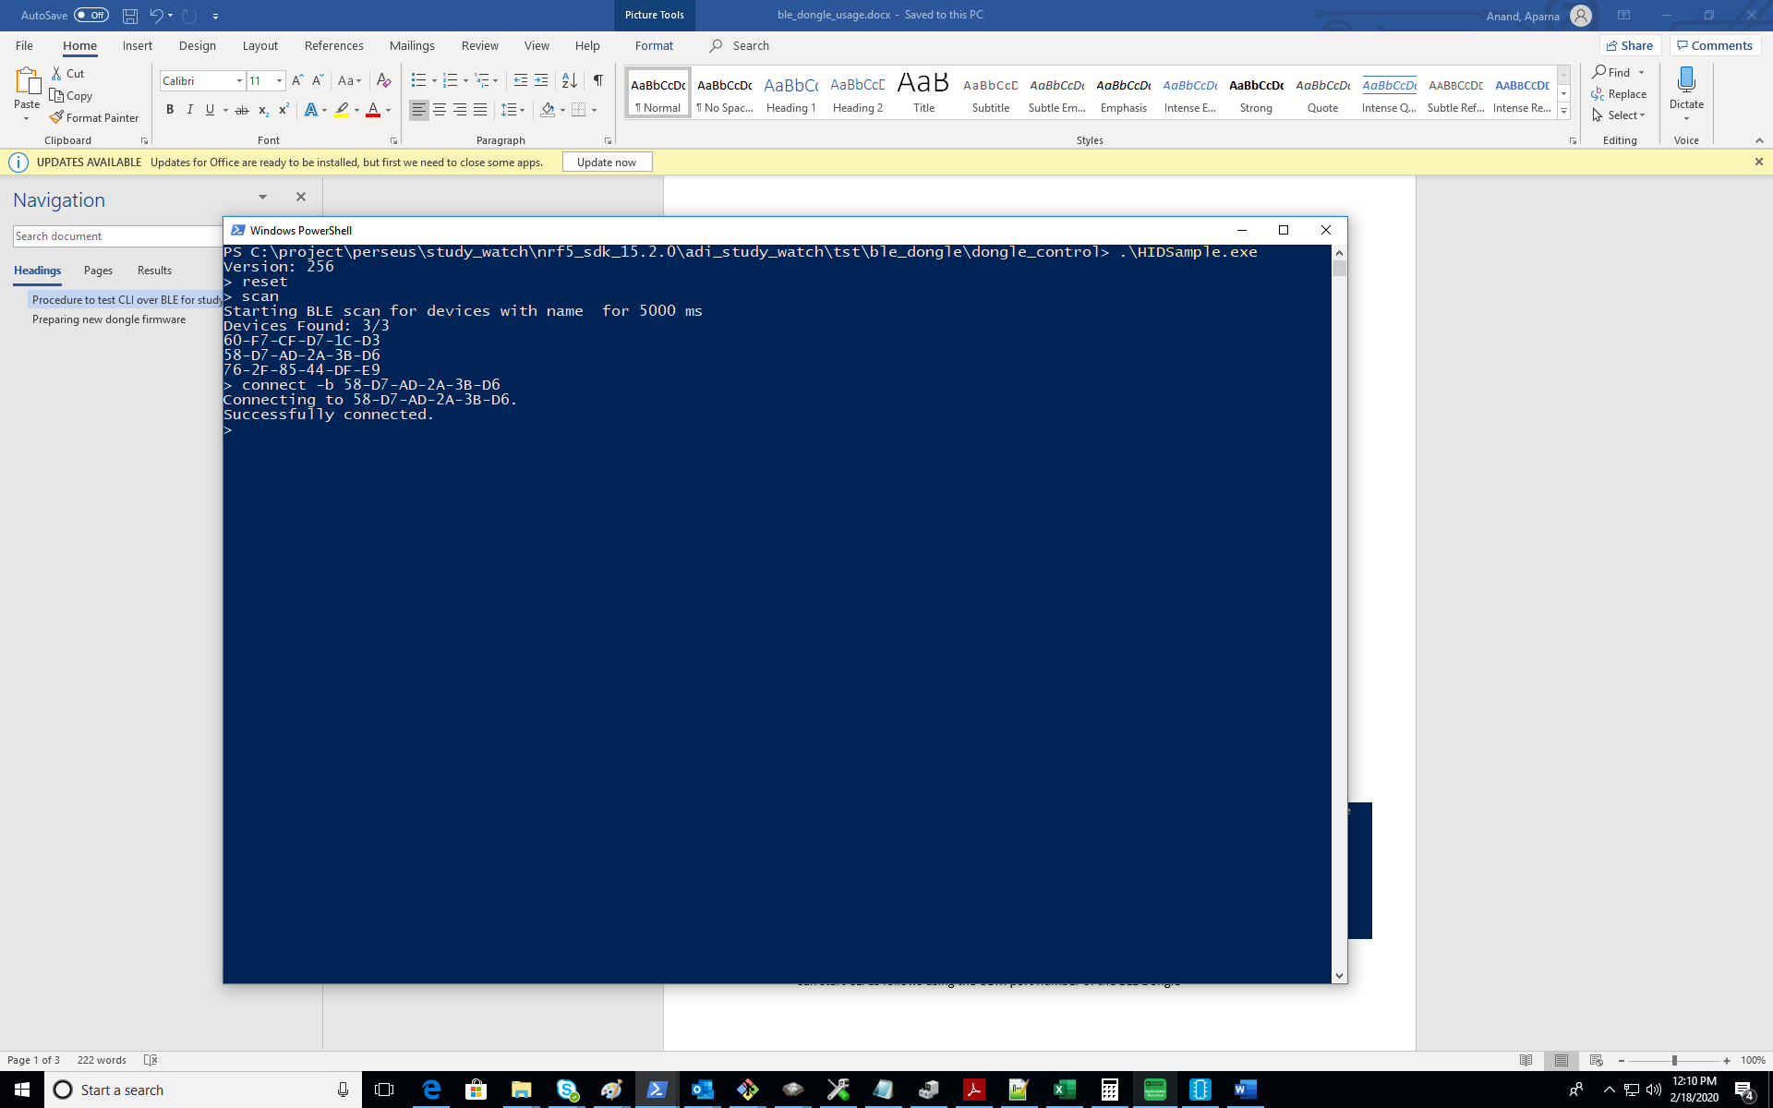

### Run CLI commands over BLE

* Can start CLI as follows using the COM port number of the BLE Dongle

